Cassandra Omni Channel

(04/27/2020)

Contents

**Use Case** 2

**Preparatory meetings:** 4

**DataStax-Cassandra TDP (Event Bus Architecture Enhancements: DataStax Cassandra) Aug 8, 2017** 5

**DataStax - Cassandra Pilot: Date: Feb, 13th 2017** 5

**DataStax Enterprise** 5

**Database** 6

**About Apache Cassandra** 7

**DataStax: How is Data Written** 7

**Development Keyspace Set up** 7

**Development Tools** 10

**Cloud Data Solutions Yammer** 11

**Conversations:** 11

Contacts: 12

Postgresql: 12

OPSCenter: 13

DSE Datastax Cassandra TLS Certificate Changes FAQ v0.2 13

## **Use Case**

***Problem Statement***

Current dialer data is stored within Recollect mainframe DB2. New text events are beginning to be published to the event bus. There needs to be consolidation of customer contact between these two channels for contact compliance purposes. There is also a need to have this data available real-time.

***Benefits***

Moving this data to an event driven repository will enable many Omni channel initiatives and help sync text message contacts to dialer history. Real time access to this data will support future contact strategies. Consolidating dialer and text data to a distributed solution will allow for legacy mainframe dialer processing to be migrated to a modernized process.

***Application Current Diagram***



***Proposed Diagram***



## **Preparatory meetings:**

Technical Governance Platform Request: [Omni Real-Time Customer Data Access](https://discoverfinancial.sharepoint.com/sites/TechGovSys/SitePages/AgendaMeeting.aspx?RequestId=4123)

ARB Project Design Summary for Omni Real-time Customer Data Access / CRD-4865: <https://discoverfinancial.sharepoint.com/sites/TechGovSys/Attachments/4123/Omni_Real_021120111237.pptx>

Meeting Minutes with Cloud Business Office (Feb 13, 2020)

<https://discoverfinancial.sharepoint.com/sites/TechGovSys/Attachments/4123/CBO_2020_0021420054023.pdf>

Scott Peterson - We will do research and circle back

Who is working on AWS portion pipeline? Kiran was helping CDS out. It is built on bare bones and provisioning pipeline.

Scott will reach out to Kiran to understand and see about the timeline, Kevita was keeping tabs on it too.

Agenda with Cloud Business Office (Feb 13, 2020)

<https://discoverfinancial.sharepoint.com/:w:/r/sites/ArchGovrn/_layouts/15/Doc.aspx?sourcedoc=%7B356F8586-81E2-4FB7-BF7E-BB7BD2B7F772%7D&file=Final%20CBO%20Agenda%2002132020.docx&action=default&mobileredirect=true>

## **DataStax-Cassandra TDP (Event Bus Architecture Enhancements: DataStax Cassandra) Aug 8, 2017**

NOTE: This project is very similar to what we are trying to do.

<https://www.yammer.com/discoverfinancial.com/uploaded_files/141764236>

## **DataStax - Cassandra Pilot: Date: Feb, 13th 2017**

<https://discoverfinancial.sharepoint.com/sites/TCS/publishedtdps/infrasvcs/Application%20Hosting%20Services/Cassandra-pilot.pdf#search=cassandra>

## **DataStax Enterprise**

DataStax Enterprise is a complete big data platform, built on Apache Cassandra, architected to manage **real-time**, **analytic**, and **enterprise** **search** data all in the same database cluster.

<https://github.discoverfinancial.com/datastax-cassandra-org/Datastax-Documentation>

(YouTube Video)

<https://www.bing.com/videos/search?q=what+is+datastax&&view=detail&mid=6B807C52781522D283316B807C52781522D28331&&FORM=VDRVRV>

## **Database**

DEV:

<https://vcld007826.na.discoverfinancial.com:8443/opscenter/index.html>

Cluster: DEVEventBusCluster (co-located)

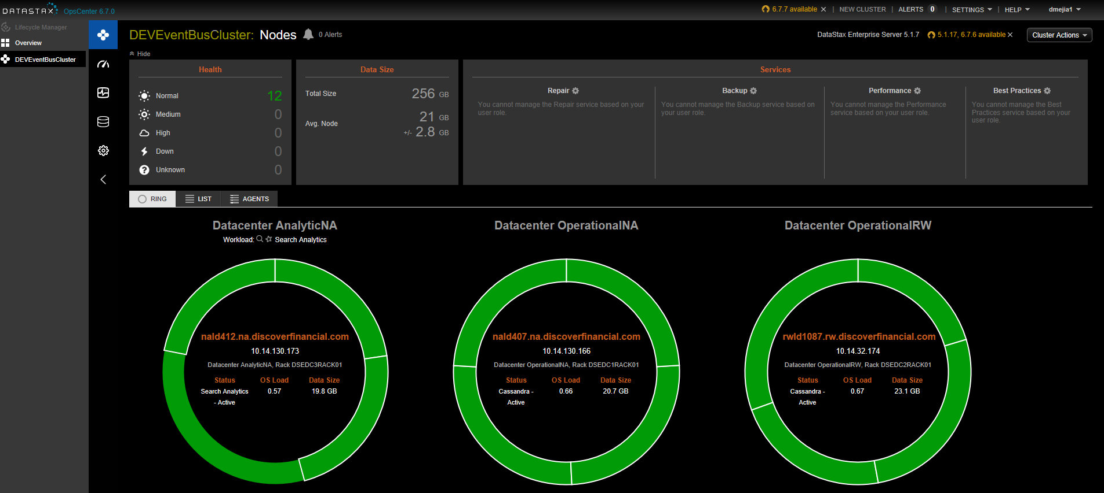

Keyspace: collections

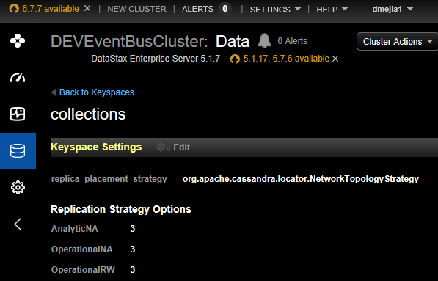

Table: text_messages

With these columns:

   account_key bigint

   text_send_tms timestamp

   phone_number text

   text_disposition_cde text

Primary Key ((account_key), text_send_date)

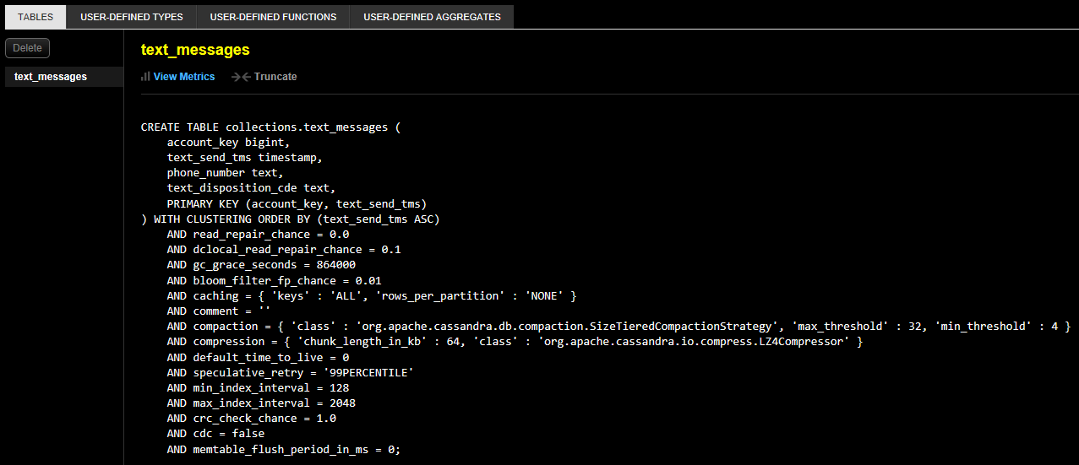

Data Modeling Concepts

<https://docs.datastax.com/en/archived/cql/3.3/cql/ddl/dataModelingApproach.html>

## **About Apache Cassandra**

<https://docs.datastax.com/en/archived/cassandra/3.0/cassandra/cassandraAbout.html>

## **DataStax: How is Data Written**

<https://docs.datastax.com/en/archived/cassandra/3.0/cassandra/dml/dmlHowDataWritten.html>

## **Development Keyspace Set up**

1. Keyspace setup. Engage CDS via [Cassadra - clouddatasolutions - CLDS](https://teams.microsoft.com/l/team/19%3af14b00c07d25455cbaef2da6f31fbba4%40thread.skype/conversations?groupId=1e980fee-f6d3-438f-a22c-abeaecc2bc99&tenantId=f3f068cf-080c-4824-a912-f8c4633bd454) or set up a meeting with clouddatasolutions [clouddatasolutions@discover.com](mailto:clouddatasolutions@discover.com). Refer to Keyspace : collections under Database heading for an example of a keyspace.
2. Column family (table) setup. Same process as keyspace setup. Refer to Table : text-messages under Database heading for an example of a table.
3. Send IDM requests for these Roles.

Datastax ~ DataStax OpsCenter View Access

Datastax ~ DSE EventBus ReadOnly Access

Below is a list of Roles available as of 04/23/2020

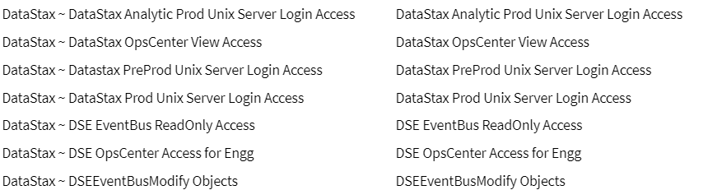

1. Request Vault set up for keyspace for your application access. Engage Vault (Hashicorp) by posting a github issue and Service Now. Here is an example of github issue with the Service Now in it: <https://github.discoverfinancial.com/entarch-org/hashicorp-vault-support/issues/1141>. With this github issue, a service now was also raised RITM1449994.
2. Download DataStax Studio, at least version 6.x (as of 04/27/2020, reach out to CDS what is the recommended version) from <https://downloads.datastax.com/#studio>. Install documentation is at <https://docs.datastax.com/en/install/6.0/install/installStudio.html>.
   1. Go to ../bin folder where you extracted DataStax Studio and start server (See Install documentation)

Ex. 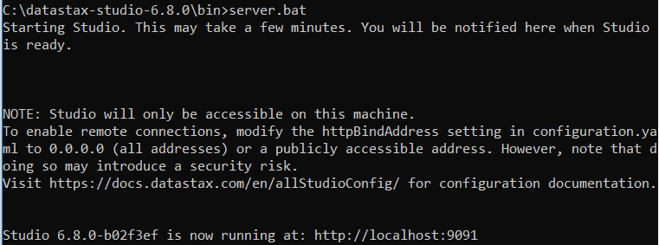

* 1. Once your server is running, you can visualize you server by entering your local ip address and port into a supported browser (Chrome or see DataStax Studio documentation).

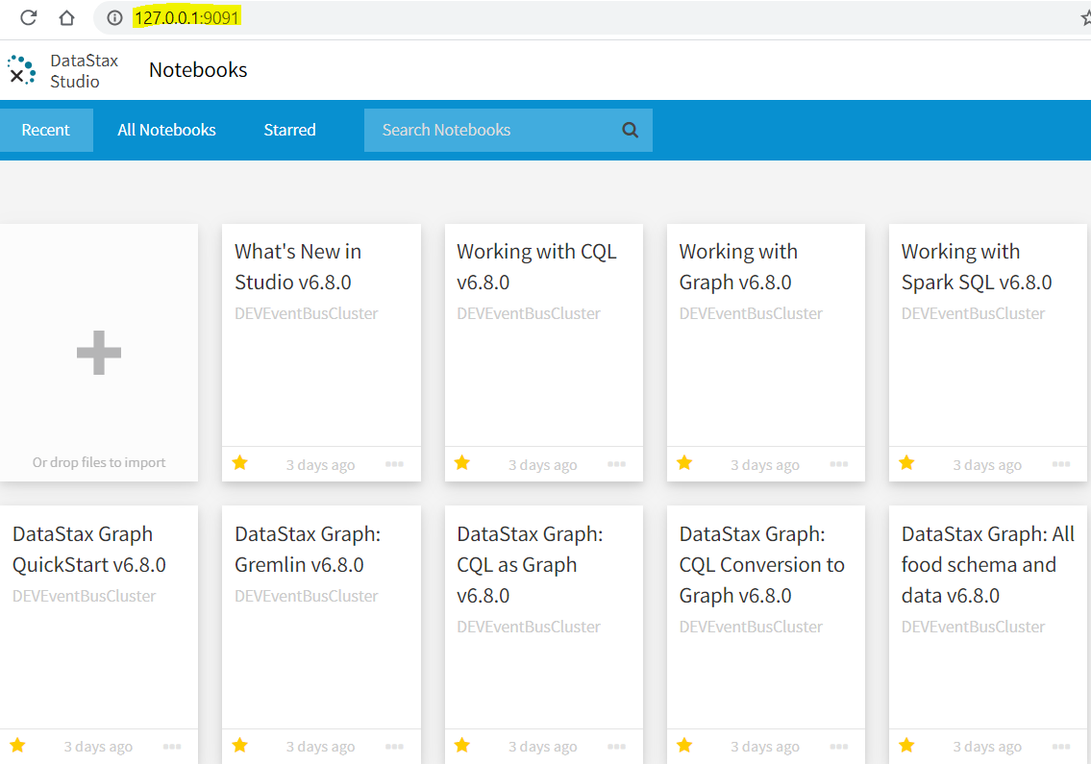

* 1. To connect to your keyspace, click connections from menu and enter the following:

Host/IP: Go to #Database and get IP address of a node you wanted to connect to from one of the datacenters.

Username: This is the vault user name from Step#4 above.

Password: This is the vault password from Step#4 above.

Truststore info: Reach out to CDS and get the jks file and Passphrase from them.

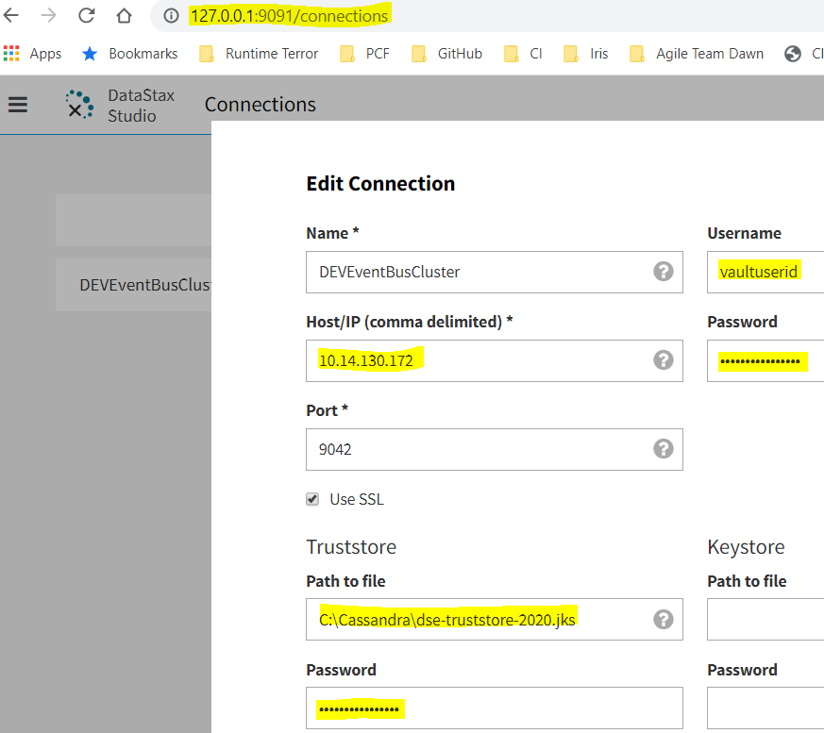

1. What Software do we need to download/Install?

The main software components of Datastax are listed below but no need to download/install them.  They’ll be used by OpsCenter that you’ll get access via IDM in Step #3.

* 1. Datastax DSE Node v5.1.7
  2. Datastax DSE OpsCenter v6.1.6- Management console for all Datastax

For more info, check Datastax-Documentation below

<https://github.discoverfinancial.com/datastax-cassandra-org/Datastax-Documentation>

(Security)

* LDAP Membership; OpsCenter roles
  + Administrator (Datastax ~ DSE OpsCenter Access for Engg)
  + View only role (Datastax ~ DSE EventBus ReadOnly Access)
* Centrify Groups
  + SEC-EN-UNX-PR-TEMP-DataStaxProd, SEC-EN-UNX-PR-TEMP-InfraServices
* Database access
  + Delegated to Vault
* Application Roles
  + *CASSANDRA - Vaut_Digital_Flux_Dev
  + *CASSANDRA - Vault_Digital_Flux_Prod
* Chef Roles
* Jenkins Roles
  + *Jenkins ~ Developer (Writer) of Datastax Cassandra Repos
  + *Continuous Integration Users - USers and Developers of Continuous Integration
* Git Roles
  + *Github Enterprise ~ Developer(writers) of Datastax Cassandra Repos
  + *Github Enterprise ~ Reader of Datastax Cassandra Repos
* AppDynamics
  + APM - Application PErformance Management ~ Production
  + APM - Application PErformance Management ~ Datastax_Enterprise_Cassandra
* CLS
  + Centralized_Logging ~ Read Only
* Vault
  + Vault_CASSANDRA_Digital_Flux_Prod ??? I don’t see this in IDM
* Unix Access
  + *DataStax - Datastax Prod Unix Server Login access
  + *DataStax - Datastax PreProd Unix Server Login access
  + *Infra Services - Privilege Unix access
  + *Infra Services - PERM Unix access

<https://github.discoverfinancial.com/datastax-cassandra-org/JavaCassandra>

## **Development Tools**

**What is CQL?**

[Cassandra Query Language (CQL)](https://docs.datastax.com/en/cql/3.3/cql/cqlIntro.html) is the primary interface into the Cassandra DBMS. Using CQL is similar to using SQL (Structured Query Language). CQL and SQL share the same abstract idea of a table constructed of columns and rows. The main difference from SQL is that Cassandra does not support joins or subqueries. Instead, Cassandra emphasizes denormalization through CQL features like collections and clustering specified at the schema level.

CQL is the recommended way to interact with Cassandra. Performance and the simplicity of reading and using CQL is an advantage of modern Cassandra over older Cassandra APIs.

The [CQL documentation](https://docs.datastax.com/en/cql/3.3/index.html) contains a [data modeling topic](https://docs.datastax.com/en/cql/3.3/cql/ddl/dataModelingApproach.html), examples, and command reference.

CQL for DataStax Enterprise 6.7

<https://docs.datastax.com/en/dse/6.7/cql/cql/cqlAbout.html>

## **Cloud Data Solutions Yammer**

Cloud Data Solutions main channel:

<https://www.yammer.com/discoverfinancial.com/#/threads/inGroup?type=in_group&feedId=15437541&view=all>

Cassandra Support Channel:

<https://teams.microsoft.com/l/channel/19%3af14b00c07d25455cbaef2da6f31fbba4%40thread.skype/General?groupId=1e980fee-f6d3-438f-a22c-abeaecc2bc99&tenantId=f3f068cf-080c-4824-a912-f8c4633bd454>

## **Conversations:**

[**Kavita Chekuri**](https://www.yammer.com/discoverfinancial.com/#/users/1630493065)

[August 6, 2019 at 12:11 PM](https://www.yammer.com/discoverfinancial.com/#/Threads/show?threadId=269246983806976)

There is a team Cloud Data Solutions - Cloud Data Solutions <datastaxcassandra@discover.com> managing Cassandra on premise and also for future AWS consumption. It is not available to consume as a service. It is utilized by few teams, mainly digital as of now. Please contact me directly for additional questions

* [**Victor Hansen**](https://www.yammer.com/discoverfinancial.com/#/users/1630472116)

[August 5, 2019 at 01:27 PM](https://www.yammer.com/discoverfinancial.com/#/Threads/show?threadId=269245838237696)

[Kavita Chekuri](https://www.yammer.com/discoverfinancial.com/#/users/1630493065) or [Kiran Dronamraju](https://www.yammer.com/discoverfinancial.com/#/users/1657909181) would be the starting point I'd recommend.

[](https://www.yammer.com/discoverfinancial.com/#/users/1657909181)

[**Kiran Dronamraju**](https://www.yammer.com/discoverfinancial.com/#/users/1657909181)

[August 5, 2019 at 01:48 PM](https://www.yammer.com/discoverfinancial.com/#/Threads/show?threadId=269245838237696)

Datastax Cassandra runs on hosted platform in our DFS data centers. This platform is a shared enterprise database for some key projects. Another effort is to build the same on cloud provider AWS. That effort is under way in Development specifically for CDS area. Install Scripts (terraform + chef) are reusable with some modifications to then instantiate the db platform for another aws account. Provisioning it as a service is something we have to evolve to, which is not in place yet.

[](https://www.yammer.com/discoverfinancial.com/#/users/1655031423)

[**Nigel Groves**](https://www.yammer.com/discoverfinancial.com/#/users/1655031423)[in reply to](https://www.yammer.com/discoverfinancial.com/#/Threads/show?threadId=269245838237696)[**Kiran Dronamraju**](https://www.yammer.com/discoverfinancial.com/#/users/1657909181)

[August 6, 2019 at 07:19 AM](https://www.yammer.com/discoverfinancial.com/#/Threads/show?threadId=269245838237696)

Thanks [Kiran Dronamraju](https://www.yammer.com/discoverfinancial.com/#/users/1657909181), so do you mean that right now if we want to POC or use Cassandra in production we would have to install and operate ourselves?

[](https://www.yammer.com/discoverfinancial.com/#/users/1657909181)

[**Kiran Dronamraju**](https://www.yammer.com/discoverfinancial.com/#/users/1657909181)

[August 6, 2019 at 08:25 AM](https://www.yammer.com/discoverfinancial.com/#/Threads/show?threadId=269245838237696)

Short answer YES. For POC you can request your project in the multi-tenancy architecture of our DEV environment. This requires keyspace i.e. database (cassandra team) and ID (vault team) setup. For Production it will more of an agreement with current platform owners i.e. Flux team and general agreement with Business Area/Architecture and general direction with shared platforms. If you'd rather do it in the AWS environment in your sub-account, we can give you the scripts which are getting ready for provision/install/configure.

## Contacts:

Victor Hansen – Application Architect

Scott Peterson - Cloud Architect

Kiran Dronamraju – Lead Cloud Engineer

Kavita Chekuri – Data Solutions Architect

## Postgresql:

<https://www.postgresql.org/>

## OPSCenter:

DEV - https://vcld007826.na.discoverfinancial.com:8443/opscenter/index.html

https://rwld1142.rw.discoverfinancial.com:8443/opscenter/index.html

## DSE Datastax Cassandra TLS Certificate Changes FAQ v0.2

https://discoverfinancial.sharepoint.com/sites/clouddatasolutions/Shared%20Documents/General/DSE%20Certificate%20Changes%20v0.2%20FAQ.pdf#search=DSE